# **BANK LOAN REPORT DOCUMENT**

**KPI VALUES**

1. **TOTAL LOAN APPLICATIONS:-**

**SELECT COUNT(*) as total_loan_applications FROM BANK_LOAN_DATA;**

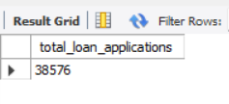

1. **MTD LOAN APPLICANTS**

SELECT COUNT(ID) AS total_loan_applications FROM BANK_LOAN_DATA WHERE MONTH(STR_TO_DATE(ISSUE_DATE, '%d-%m-%Y')) = 12 AND YEAR(STR_TO_DATE(ISSUE_DATE, '%d-%m-%Y')) = 2021;

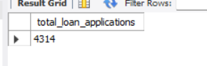

1. **PMTD LOAN APPLICANTS**

SELECT COUNT(id) AS Total_Applications FROM bank_loan_data WHERE MONTH(STR_TO_DATE(ISSUE_DATE, '%d-%m-%Y')) = 11;

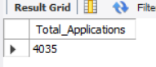

**## TOTAL FUNDED AMOUNT**

1. **SELECT SUM(LOAN_AMOUNT) AS TOTAL_FUNDED_AMOUNT FROM BANK_LOAN_DATA;**

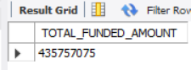

**## MTD TOTAL FUNDED AMOUNT**

1. **SELECT SUM(LOAN_AMOUNT) AS TOTAL_FUNDED_AMOUNT FROM BANK_LOAN_DATA**

**WHERE MONTH(STR_TO_DATE(ISSUE_DATE, '%d-%m-%Y'))=12;**

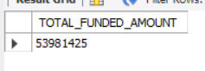

**## PMTD TOTAL FUNDED AMOUNT**

1. **SELECT SUM(LOAN_AMOUNT) AS TOTAL_FUNDED_AMOUNT FROM BANK_LOAN_DATA**

**WHERE MONTH(STR_TO_DATE(ISSUE_DATE, '%d-%m-%Y'))=11;**

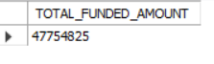

**Total Amount Received**

**SELECT SUM(total_payment) AS Total_Amount_Collected FROM bank_loan_data**



**MTD Total Amount Received**

**SELECT SUM(total_payment) AS Total_Amount_Collected FROM bank_loan_data**

**WHERE MONTH(issue_date) = 12**



**PMTD Total Amount Received**

**SELECT SUM(total_payment) AS Total_Amount_Collected FROM bank_loan_data**

**WHERE MONTH(issue_date) = 11**



**LOAN STATUS**

**SELECT loan_status, COUNT(id) AS LoanCount, SUM(total_payment) AS Total_Amount_Received, SUM(loan_amount) AS Total_Funded_Amount, AVG(int_rate * 100) AS Interest_Rate, AVG(dti * 100) AS DTI FROM bank_loan_data GROUP BY loan_status**

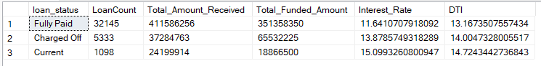

**SELECT**

**loan_status,**

**SUM(total_payment) AS MTD_Total_Amount_Received,**

**SUM(loan_amount) AS MTD_Total_Funded_Amount**

**FROM bank_loan_data**

**WHERE MONTH(issue_date) = 12**

**GROUP BY loan_status**

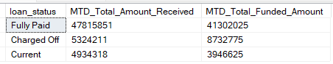

**BANK LOAN REPORT | OVERVIEW**

**MONTH**

**SELECT**

**MONTH(issue_date) AS Month_Munber,**

**DATENAME(MONTH, issue_date) AS Month_name,**

**COUNT(id) AS Total_Loan_Applications,**

**SUM(loan_amount) AS Total_Funded_Amount,**

**SUM(total_payment) AS Total_Amount_Received**

**FROM bank_loan_data**

**GROUP BY MONTH(issue_date), DATENAME(MONTH, issue_date) ORDER BY MONTH(issue_date)**

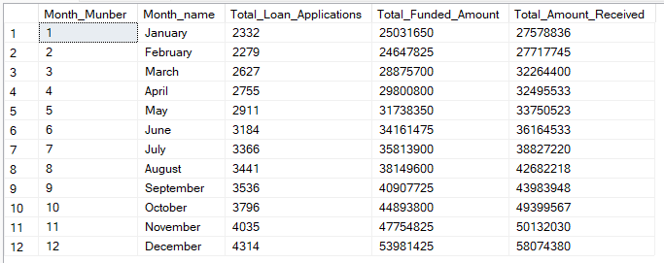

**STATE**

**SELECT**

**address_state AS State,**

**COUNT(id) AS Total_Loan_Applications,**

**SUM(loan_amount) AS Total_Funded_Amount,**

**SUM(total_payment) AS Total_Amount_Received**

**FROM bank_loan_data**

**GROUP BY address_state**

**ORDER BY address_state**

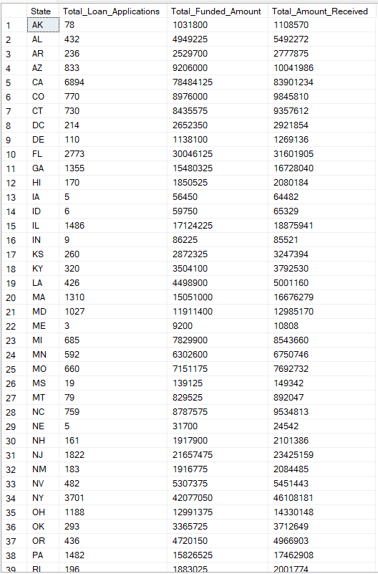

**TERM**

**SELECT**

**term AS Term,**

**COUNT(id) AS Total_Loan_Applications,**

**SUM(loan_amount) AS Total_Funded_Amount,**

**SUM(total_payment) AS Total_Amount_Received**

**FROM bank_loan_data**

**GROUP BY term**

**ORDER BY term**

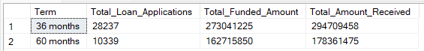

**EMPLOYEE LENGTH**

**SELECT**

**emp_length AS Employee_Length,**

**COUNT(id) AS Total_Loan_Applications,**

**SUM(loan_amount) AS Total_Funded_Amount,**

**SUM(total_payment) AS Total_Amount_Received**

**FROM bank_loan_data**

**GROUP BY emp_length**

**ORDER BY emp_length**

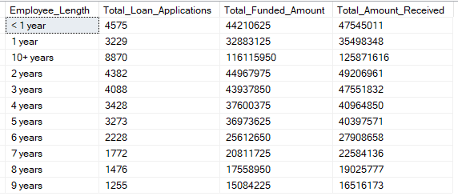

**PURPOSE**

**SELECT**

**purpose AS PURPOSE,**

**COUNT(id) AS Total_Loan_Applications,**

**SUM(loan_amount) AS Total_Funded_Amount,**

**SUM(total_payment) AS Total_Amount_Received**

**FROM bank_loan_data**

**GROUP BY purpose**

**ORDER BY purpose**

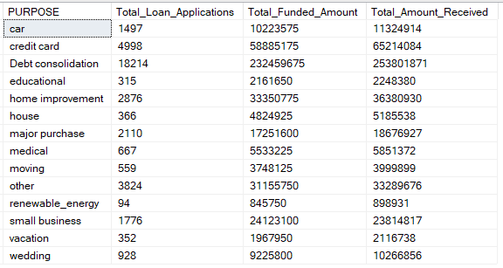

**HOME OWNERSHIP**

**SELECT**

**home_ownership AS Home_Ownership,**

**COUNT(id) AS Total_Loan_Applications,**

**SUM(loan_amount) AS Total_Funded_Amount,**

**SUM(total_payment) AS Total_Amount_Received**

**FROM bank_loan_data**

**GROUP BY home_ownership**

**ORDER BY home_ownership**

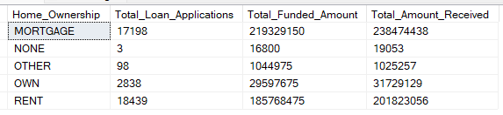

***Note: We have applied multiple Filters on all the dashboards. You can check the results for the filters as well by modifying the query and comparing the results.***

***For e.g***

***See the results when we hit the Grade A in the filters for dashboards.***

***SELECT***

***purpose AS PURPOSE,***

***COUNT(id) AS Total_Loan_Applications,***

***SUM(loan_amount) AS Total_Funded_Amount,***

***SUM(total_payment) AS Total_Amount_Received***

***FROM bank_loan_data***

***WHERE grade = 'A'***

***GROUP BY purpose***

***ORDER BY purpose***